21.88: a) 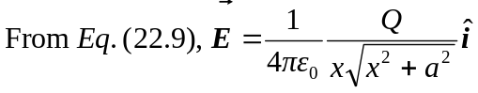
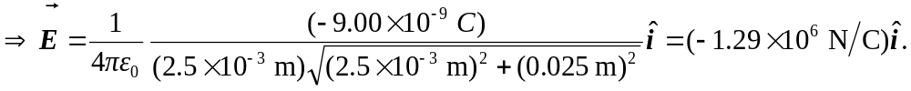
(b) The electric field is less than that at the same distance from an infinite line of charge 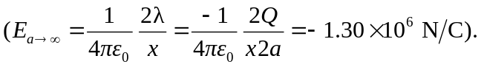 This is because in the approximation, the terms left off were negative.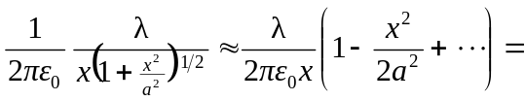
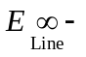 (Higher order terms).
c) For a 1% difference, we need the next highest term in the expansion that was left off to be less than 0.01:
